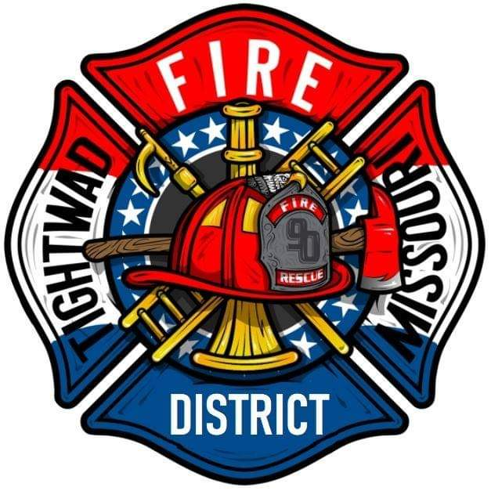 | AGENDA  Tightwad Fire Protection District  ^{7th} Meeting of the 17th Board of Directors  Monday, June 20, 2022, at 6:00 pm  Tightwad Fire Station  11585 MO Highway 7, Clinton, MO 64735  660-477-3456  www.tightwadfpd.org

- Call to order by the Chair

- Adjourn to Closed Meeting pursuant to RSMo 610.021(1)(3)(13)
  - Personnel
  - Legal
  - OGD
  - Vacancies
  - Pay

3. Adjourn

