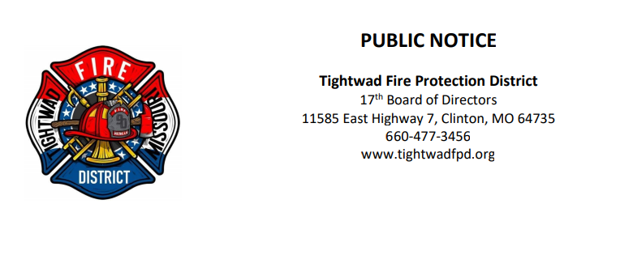

The 17th Board of Directors of the Tightwad Fire Protection District will meet:

Tightwad Fire Protection District
^{8th} Meeting of the 17th Board of Directors
Thursday, July 7, 2022, at 6:00 pm
Tightwad Village Building
11561 East Highway 7, Clinton, MO 64735
660-477-3456
www.tightwadfpd.org

