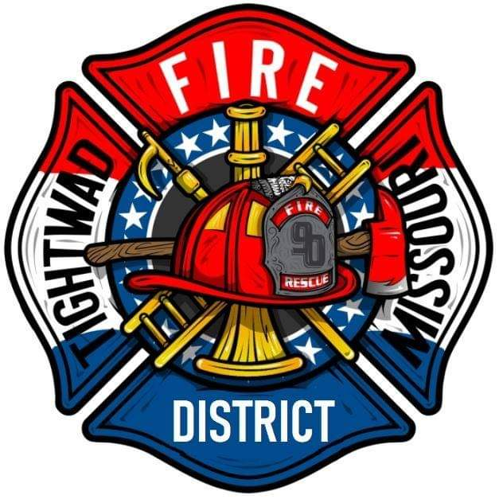 | AGENDA  Tightwad Fire Protection District  ^{13th} Meeting of the 17th Board of Directors  Thursday, Dec 15th , 2022, at 6:00 pm  Tightwad Fire Station  11585 SouthEast Highway 7, Clinton, MO 64735  660-477-3456  www.tightwadfpd.org
- Call to order by the Chair

2. Pledge of Allegiance or Chaplain’s opening prayer
3. Approval of Minutes
a. Nov 17th , 2022
4. Chief’s Report
5. Treasurer’s Report
a. approval of bills
6. New Business
a. Resignation of Training Officer
8. Citizen Comments
9. Adjourn to Closed Session
10. Closed Session-Adjourn to Closed Meeting pursuant to RSMo 610.021(1)(3)(13)
a. legal
11. Adjourn Closed Session
12. Call to order – resume general session
13. Adjourn

