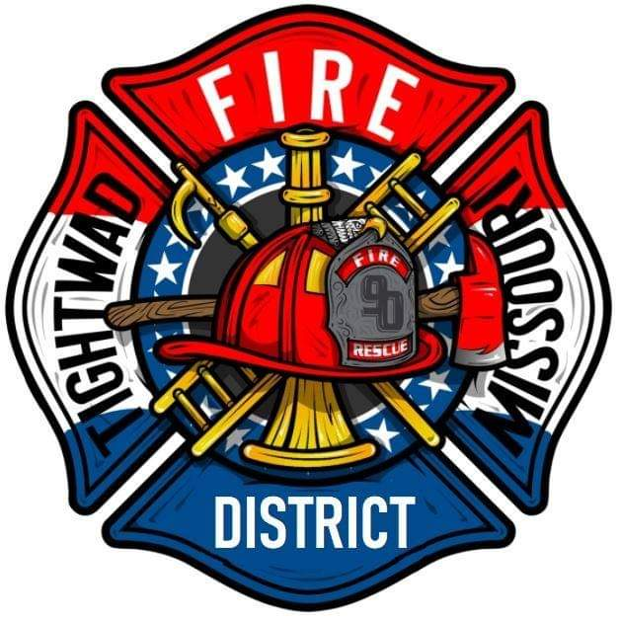 | AGENDA  Tightwad Fire Protection District  ^{12th} Meeting of the 17th Board of Directors  Thursday, Oct 20, 2022, at 6:00 pm  Tightwad Fire Station  11585 SouthEast Highway 7, Clinton, MO 64735  660-477-3456  www.tightwadfpd.org
- Call to order by the Chair

2. Pledge of Allegiance or Chaplain’s opening prayer
3. Approval of Minutes
a. Sept 15, 2022
b. Sept 29, 2022
4. Chief’s Report
5. Treasurer’s Report
a. approval of bills
6. New Business
a. Burn Ban Ordinance Draft Approval
7. Old Business
a. Official resignation of Board Secretary Veatch
b. Appointment of Board Secretary Kuhns
8. Citizen Comments
9. Adjourn to Closed Session
10. Closed Session-Adjourn to Closed Meeting pursuant to RSMo 610.021(1)(3)(13)
a. legal
b. personnel
11. Adjourn Closed Session
12. Call to order – resume general session
a. Lease resolution
13. Adjourn

