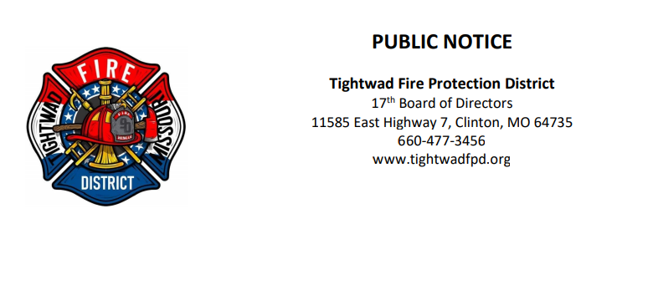

The 17th Board of Directors of the Tightwad Fire Protection District will meet: Special Meeting

Tightwad Fire Protection District
Meeting of the 17th Board of Directors
Thursday, February 2nd, 2023, at 6:00 pm
Tightwad Fire Hall
11585 East Highway 7, Clinton, MO 64735
660-477-3456
www.tightwadfpd.org

