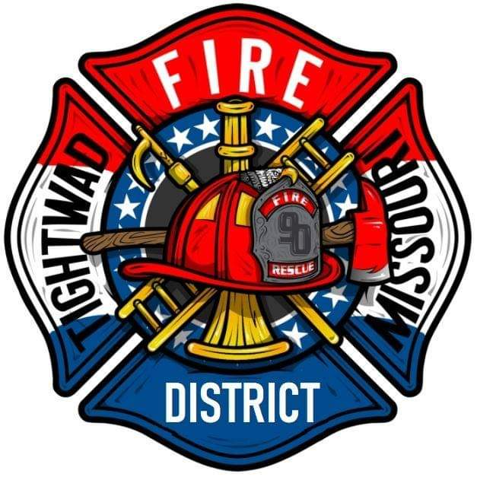 | AGENDA  Tightwad Fire Protection District  ^{13th} Meeting of the 17th Board of Directors  Thursday, Feb 16th , 2023, at 6:00 pm  Tightwad Fire Station  11585 SouthEast Highway 7, Clinton, MO 64735  660-477-3456  www.tightwadfpd.org
- Call to order by the Chair

- Pledge of Allegiance
- Approval of Minutes
  - Feb 02, 2023
- Treasurer’s Report
- Chief’s Report
- Old Business
  - District Manager
  - Posting of Meeting Notice (permanent)
  - NIMS Training (National Incident management System)
  - Records Storage (Titles for Vehicles etc., who has access to what)
  - Fire Ban Ordinance
  - Lease with Village
- New Business
  - Attorney
  - Seeking Bids for Board Room
  - ADA Bathroom
  - Keys for Board Members
- Adjourn Open Session
- Closed Session
  - Personnel 610.02 1(1)(3)(13)
- Open Session
- 12. Call to order – resume general session
- Citizen Comments
- 13. Adjourn

