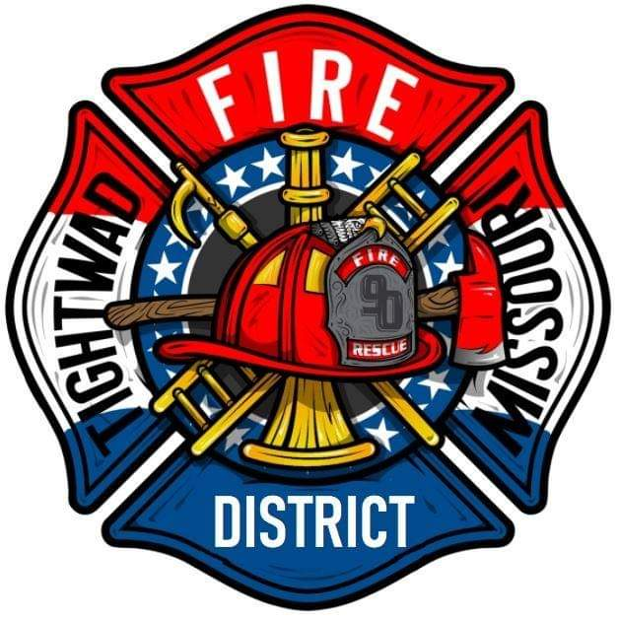 | AGENDA  Tightwad Fire Protection District  ^{9th} Meeting of the 17th Board of Directors  Tuesday, August 23, 2022, at 6:00 pm  Tightwad Village Hall  11561 East Highway 7, Clinton, MO 64735  660-477-3456  www.tightwadfpd.org

- Call to order by the Chair

2. Pledge of Allegiance or Chaplain’s opening prayer
3. Approval of Minutes
a. July 7, 2022
4. Chief’s Report
5. Treasurer’s Report
6. New Business
A. Approval of budget – 2022 Budget Resolution
B. 7:00 pm Recess for Public Hearing
2022 Ad Valorem Property Tax Levy Rate (s) Resolution
7. Old Business
8. Citizen Comments
9. Adjourn to Closed Session
10. Closed Session-Adjourn to Closed Meeting pursuant to RSMo 610.021(1)(3)(13)

