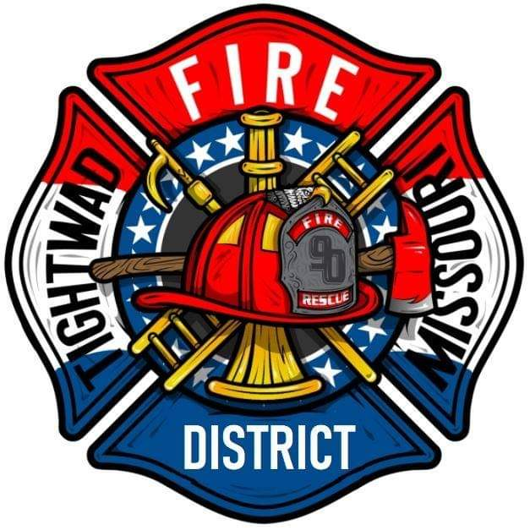 | AGENDA  Tightwad Fire Protection District  ^{9th} Meeting of the 17th Board of Directors  Thursday, Sep 15, 2022, at 6:00 pm  Tightwad Village Hall  11561 East Highway 7, Clinton, MO 64735  660-477-3456  www.tightwadfpd.org

- Call to order by the Chair

2. Pledge of Allegiance or Chaplain’s opening prayer
3. Approval of Minutes
a. Aug 23 2022
4. Chief’s Report
5. Treasurer’s Report
a. approval of bills
6. New Business
a. Spatial Data Research, Inc.- sales tax mapping information required for the implementation and collection of the District's sales tax.
7. Old Business
8. Citizen Comments
9. Adjourn to Closed Session
10. Closed Session-Adjourn to Closed Meeting pursuant to RSMo 610.021(1)(3)(13)
a. legal
b. personnel

