Fire Chief’s Report
April 19, 2023
- Operations
- Incidents
i. (5) Med (0) Invest (01) MVA (4) g.fire (1) WBC (1) s.fire– (since last report)
ii. (17) Med, (12) G. Fire, (2) WBC, (3) S. Fire, (5) MVA, (01) Invest (year to date)

Training
- The first Thursday of month Clinton Fire is doing training with a lot of us in Henry county. Going over somethings out of basic fire and asking us what else we can do together to help each other out.

- Change
- Working on Standard Operating Guidelines/Procedures, plus we will be getting new updated Policies we follow from Golden Valley Medical Hospital Director.

- Vehicle/Equipment Maintenance / Radio’s

- Brush Truck #2 – At Mary’s
- Brush Truck #3 –Batteries have been order… the some size in it now.
- Tanker #2 -welding is done

- Accidents/Work Comp. & Claims/ Near misses.
- ( 0 ) Work Comp. Near misses (0).
- Major Activities
- Community/Public relations
- We did a control burn for Darleen W On 300 rd. she gave us a donation for doing that for her. We have 1 more to do but need a calm day to do that one.
- Had a Chiefs meeting in Warsaw and talk about doing Extraction play day on the new grounds. Will be contacted when they have a date set.
- Media Relations
Facebook New page likes 0%(3), Post Reach up 112%(1400) Post Engagement up 243%(683).
- Special Projects
- NONE.
- .
- .
- .
- Inter-governmental

- Administration
- Building and Grounds ( including radio towers )
- New tower is going up on Tuesday the 25th. Our antenna will be moved to it and it will be at 100 Ft. them we will be getting Dispatches Repeater they are using right now which will be put in a shed out of weather at no cost!!
- Waiting to hear back from Kevin Kelguard on what it will cost to run some plug in’s and safety lights on the outside of building.
- Computer and Telephone Systems
- Need to see if we can get new High speed Internet yet?

- For Consideration by the Board
- Proposed policy changes.
- .
- .
- .
- Purchases/Contracts

- Personnel recommendations
- Employment - No new hires
- Promotion/Demotion/other Changes requiring Board approval – Unknown
- Discipline – Need to talk in close meeting about 1

- Resignations/Terminations – None

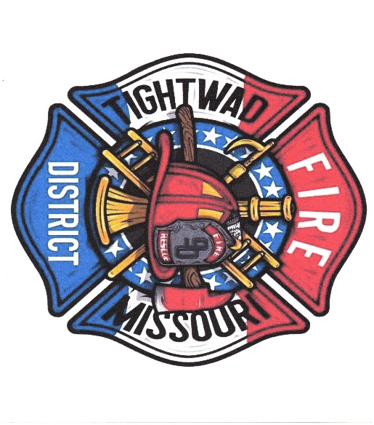
Chief Chuck Willis ( 750 )
Tightwad Fire PD
Station: 1-660-477-3456
Cell: 1-660-723-5373
Email tightwadF.D@outlook.com

Here to Protect and sever our Community In Hard Times

