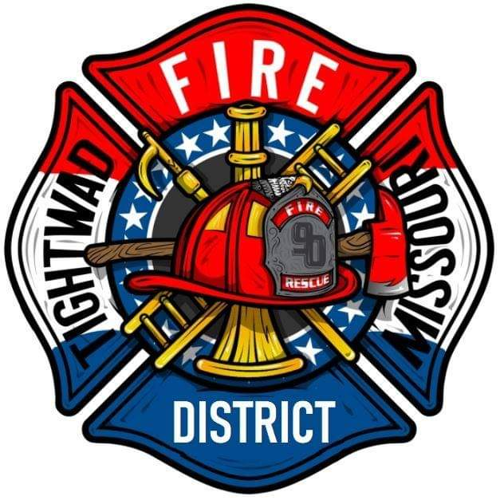 | AGENDA  Tightwad Fire Protection District  ^{8th} Meeting of the 17th Board of Directors  Thursday, July 7, 2022, at 6:00 pm  Tightwad Village Hall  11561 East Highway 7, Clinton, MO 64735  660-477-3456  www.tightwadfpd.org

- Call to order by the Chair

2. Pledge of Allegiance of Chaplain’s opening prayer
3. Approval of Minutes
a. June 9, 2022
b. June 20, 2022
4. Chair’s Comments
A. HR
B. Grievances
C. Trainer
5. Chief’s Report
6. Treasurer’s Report
7. New Business
A. Approval of Direct Deposit of Tax Funds
B. Meeting Packets
C. Garage Sale Items
D. Continuous Meeting Date Change
8. Old Business
Olde Glory Days
9. Citizen Comments
10. Adjourn

