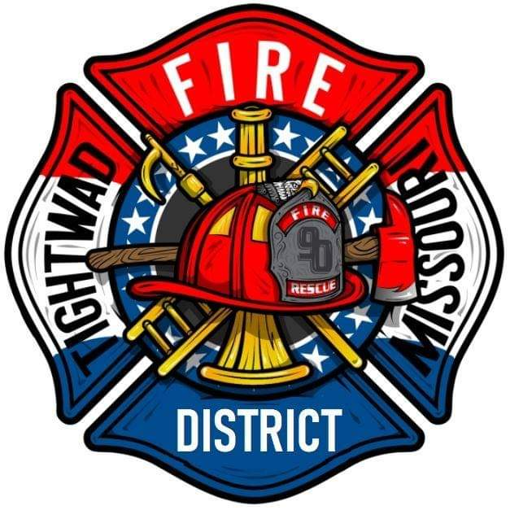 | AGENDA  Tightwad Fire Protection District  ^{13th} Meeting of the 17th Board of Directors  Thursday, Jan 19th , 2023, at 6:00 pm  Tightwad Fire Station  11585 SouthEast Highway 7, Clinton, MO 64735  660-477-3456  www.tightwadfpd.org
- Call to order by the Chair

2. Pledge of Allegiance or Chaplain’s opening prayer
3. Approval of Minutes
a. Dec 15th , 2022
b. Jan 04th. 2023
4. Chief’s Report
5. Treasurer’s Report
6. New Business
a. Standing rule #1
b. Start having working Meetings in addition to regular meetings.
c. Appoint district manger
d. Grants
8. Citizen Comments
12. Call to order – resume general session
13. Adjourn

