2
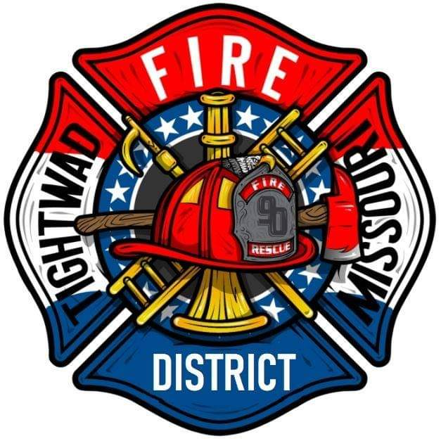 | AGENDA  Tightwad Fire Protection District  Meeting of the 17th Board of Directors  Thursday, February 02, 2023, at 6:00 pm  Tightwad Fire Station  11585 MO Highway 7, Clinton, MO 64735  660-477-3456  www.tightwadfpd.org

- Call to order by the Chair
- Approve meeting minutes from 01/19/2023
- New Business

- 4 Adjourn

