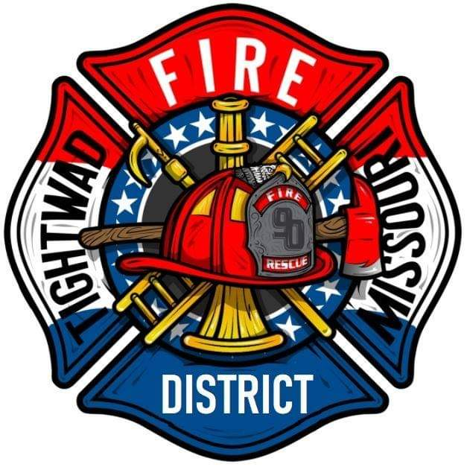 | AGENDA  Tightwad Fire Protection District  ^{6th} Meeting of the 17th Board of Directors  Thursday, June 9, 2022, at 6:00 pm  Village Building  11561 East Highway 7, Clinton, MO 64735  660-477-3456  www.tightwadfpd.org

- Call to order by the Chair

- Pledge of Allegiance or Chaplain’s Opening Prayer

- Approval of the Minutes from Previous Meeting
  - May 12, 2022

- Chief’s Report

- Treasurer’s Report

- Approve Payment of Bills

- General Orders
- Disposal of Additional Assets – Purple Wave agreement signature
- Trade agreement Signature

- Unfinished Business
  - Expansion of District boundaries
  - USDA REDLG interest free loan application
  - Authorization to draft an ambulance services proposal

- New Business
  - Mowing
  - Security Cameras vote
  - CPR & Lifeflight Training
  - Olde Glory Days
  - Public Questions

- Adjourn to Closed Meeting pursuant to RSMo 610.021(1)(3)(13)
  - Personnel

11. Adjourn

